Networking
Practical learning :
- Assigning IP addresses to the interfaces.
- Making subnets in any type of IP classes
- Configuration of routing protocols
RIP
OSPF
EIGRP
BGP
- Configuration of VLANS and its types

* Assigning IP addresses to the interfaces :
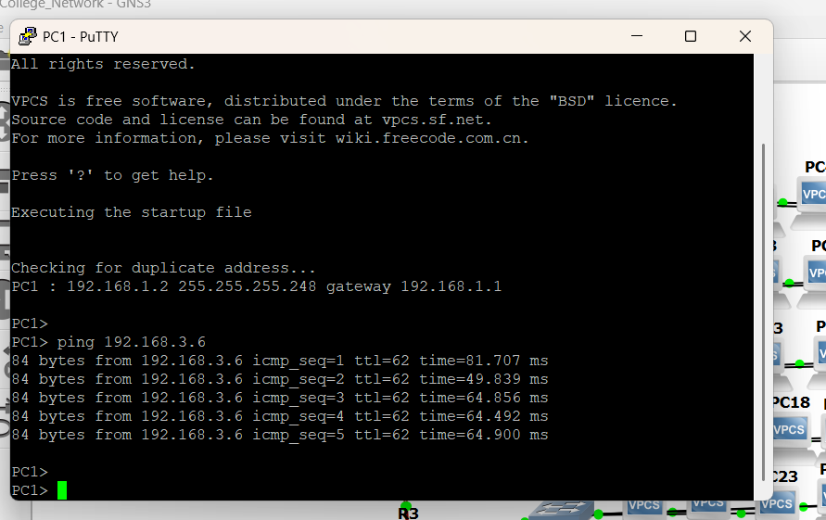

➤ What it means:
Assigning an IP address allows a device to communicate in a network. Each interface (like Ethernet0, FastEthernet1, etc.) in a router or switch needs a unique IP address.
➤ Steps:
192.168.1.2 → IP address of the PC
255.255.255.248→ Subnet mask
192.168.1.1 → Default gateway
=> Verify the configuration: show
=> Test connectivity: ping 192.168.1.1

Configuration of Routers:

enable
configure terminal
interface fastEthernet0/0
ip address 192.168.1.1 255.255.255.0
no shutdown
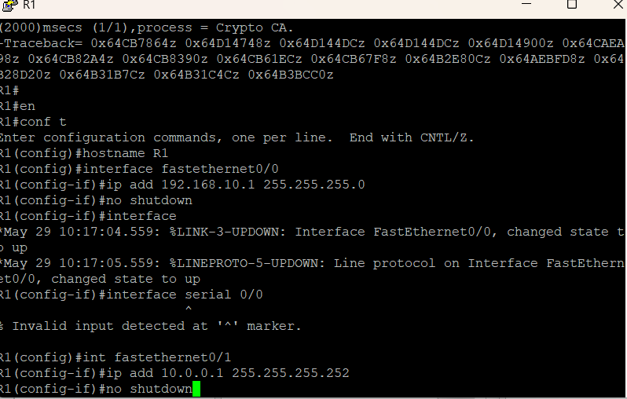
Similarly for R2 and R3
RIP : (Routing Information Protocol ) :-
A distance-vector protocol that uses hop count as a metric.
Slow convergence and supports up to 15 hops.
Simple but outdated, mostly used for learning purposes.
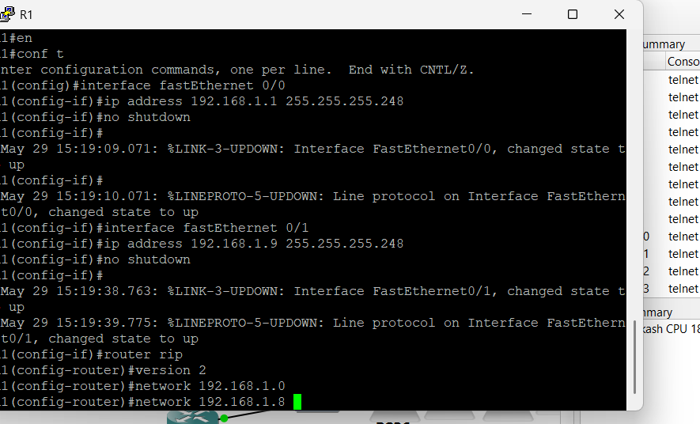

Steps:
Router(config)# router rip
Router(config-router)# version 2
Router(config-router)# network 192.168.1.0
Router(config-router)# exit

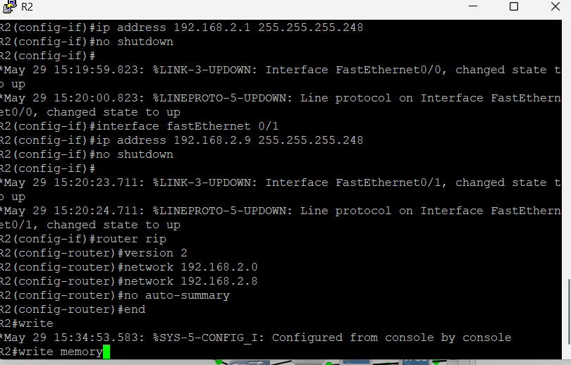

Similarly for the router 3

➤OSPF (Open Shortest Path First) :-

A link-state protocol that uses cost based on bandwidth.
It converges quickly and supports large, hierarchical networks.
Open standard, widely used in enterprise networks.
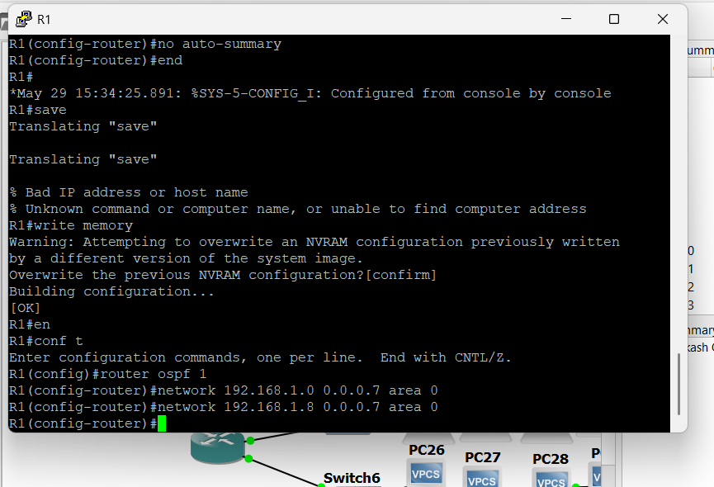

➤Steps :
Router(config)# router eigrp 10
Router(config-router)# network 192.168.1.0
Router(config-router)# no auto-summary
Router(config-router)# exit
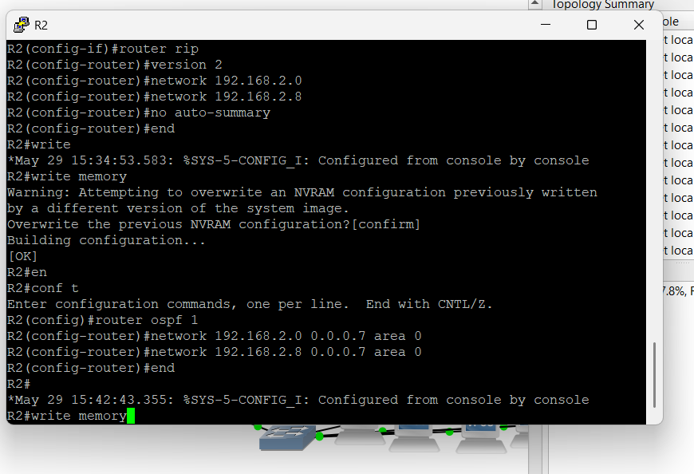

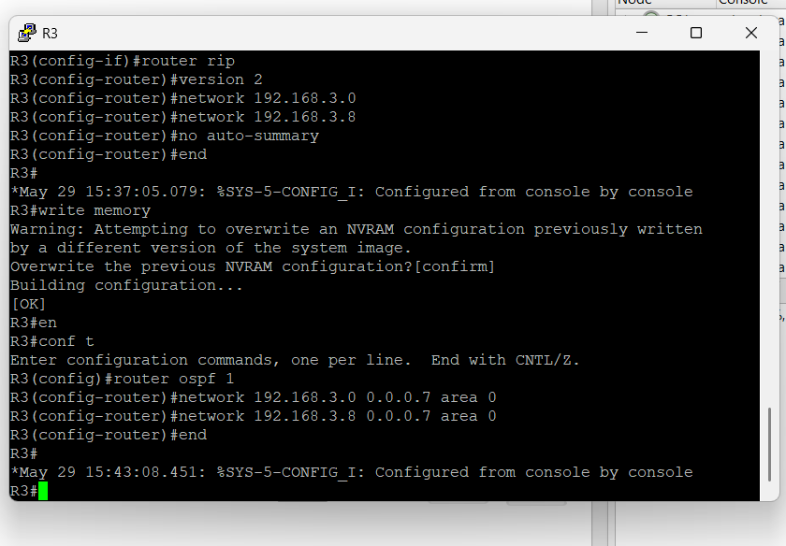

➤ EIGRP (Enhanced Interior Gateway Routing Protocol) :
A Cisco proprietary hybrid protocol (distance vector + link state features).
Fast convergence and efficient use of bandwidth.
Supports VLSM, unequal-cost load balancing, and is scalable.
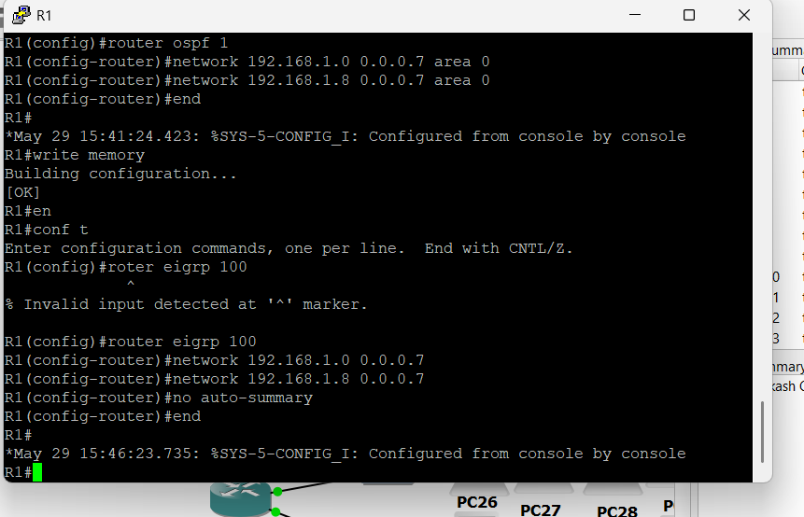

➤Steps :
Router(config)# router eigrp 10
Router(config-router)# network 192.168.1.0
Router(config-router)# no auto-summary
Router(config-router)# exit
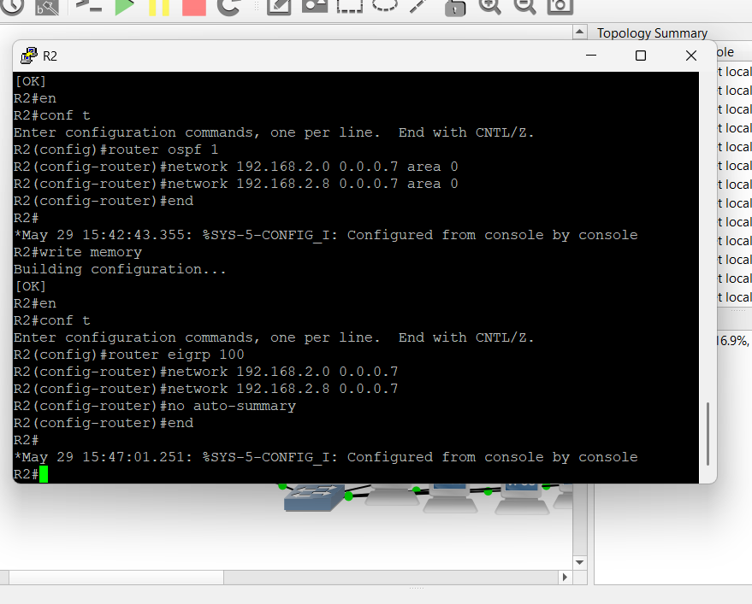

➤ BGP (Border Gateway Protocol) :
A path-vector protocol used to route between autonomous systems (on the internet).
Used by ISPs and large networks for global routing decisions.
Scalable and policy-based, but complex to configure.

➤Steps:
Router(config)# router bgp 65001
Router(config-router)# neighbor 10.0.0.2 remote-as 65002
Router(config-router)# network 192.168.1.0 mask 255.255.255.0
Router(config-router)# exit

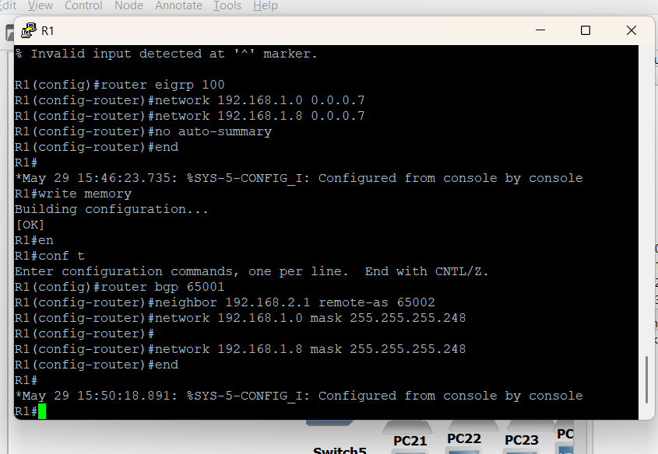

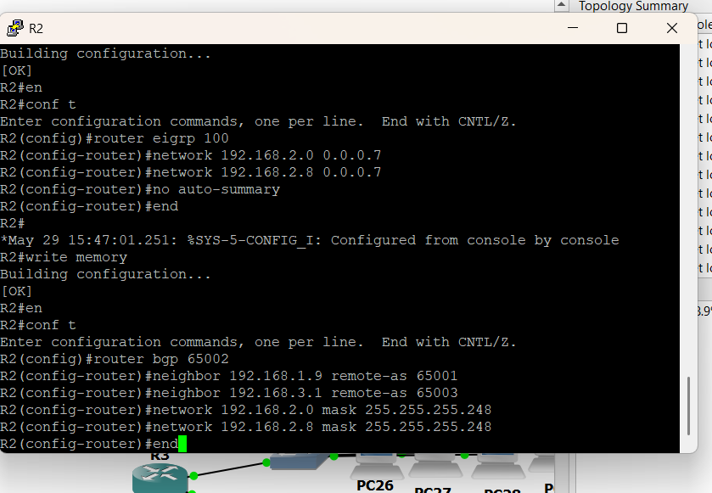
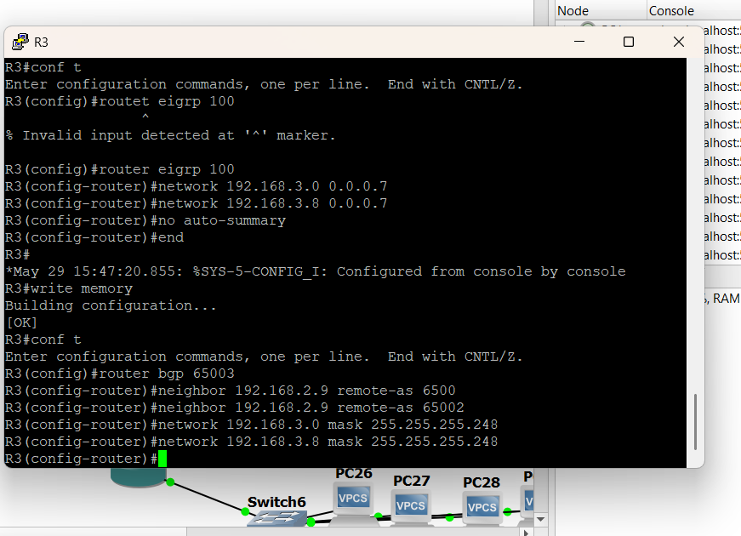

4. Configuration of VLANs and Its Types
➤ What is a VLAN?
- Virtual LAN allows segmentation of a physical network into multiple logical networks.
- Devices in different VLANs can't communicate without a router or Layer 3 switch.
➤ Types of VLANs:
- Default VLAN (VLAN 1) – All switch ports are in this by default.
- Data VLAN – Carries user-generated traffic.
- Voice VLAN – Used for VoIP traffic.
- Management VLAN – Used to manage network devices.
- Native VLAN – Used for untagged traffic on trunk ports.
➤ Steps to Create and Assign VLAN:
Switch> enable
Switch# configure terminal
Switch(config)# vlan 10
Switch(config-vlan)# name Sales
Switch(config-vlan)# exit

Switch(config)# interface fastEthernet 0/1
Switch(config-if)# switchport mode access
Switch(config-if)# switchport access vlan 10
Switch(config-if)# exit

➤ To Configure Trunk Port (for multiple VLANs):
⁼Switch(config)# interface fastEthernet 0/24
Switch(config-if)# switchport mode trunk
Switch(config-if)# switchport trunk native vlan 1

